“AM I AUTISTIC?” VIDEO HANDOUT
Getting an Autism Diagnosis (and beyond) in Saskatchewan

By Janet Sebelius

Am I Autistic? How to Get a Diagnosis (and Beyond)
- Don’t just wonder, seek help!
- Saskatchewan has doctors, psychiatrists and psychologists who can assist with getting a diagnostic assessment
- Diagnosing adults is not as common as diagnosing children but anyone can be diagnosed at any given time

Where do I go for an Assessment?
- A family doctor is a great place to start
- They can point you in the right direction for a referral
- The government of Saskatchewan website also has valuable information pertaining to Autism
- Medical professionals utilize the Diagnostic and Statistical Manual of Mental Disorders which is commonly known as the DSM-5

I have Autism…What Do I Do Now?
- Seek services that can help you
- This begins with a consultation with a professional intake coordinator
- From there, they will provide you information on how you can access several unique programs that will fit within your specific needs
- Some examples can include social programs, one on one counselling and therapy sessions, behavioural treatment plans, mental health programs, group-based therapy programs, residential opportunities, job placements, recreational and physical fitness programs, life-skills programs etc.
- You may also seek a consultant who can provide you with goals by developing concrete data plans

It’s Ok to be Autistic
- A diagnosis of Autism does not change who you are as a person
- A diagnosis does provide answers to complex questions
- Having an Autism diagnosis may make you eligible for new community support
- The Autistic community is as varied as flecks of sand on a beach; each person has their own unique challenges and gifts
- Finding where you belong in a world-wide community can be the start of an extra-ordinary journey!

Resources
- www.autismcanada.org
- www.cdc.gov/ncbddd/autism
- www.autismservices.ca, 306-665-7013
- http://www.rqhealth.ca/department/mental-health/adult-mental-health-clinics, 306-766-7800
- www.saskatchewan.ca (SK Ministry of Health and Autism Services)

*Please note that this project is completed by a SK resident

This resource was made in collaboration with:
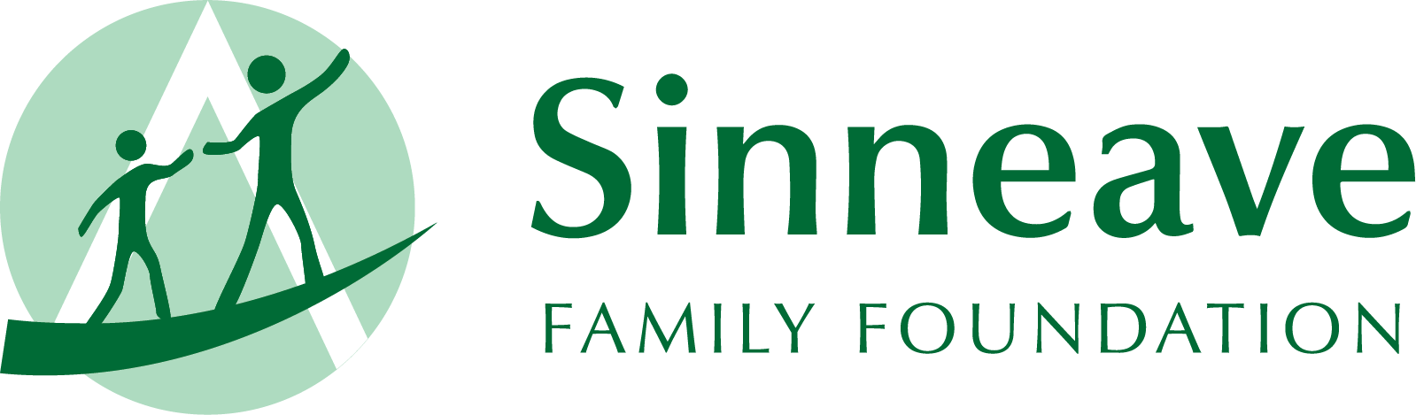
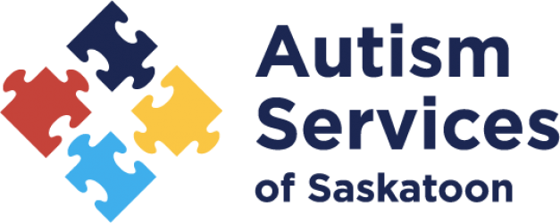
a
C A L G A R Y

